Appendix 12: SWIFT Child Safety Module Interview: Participants




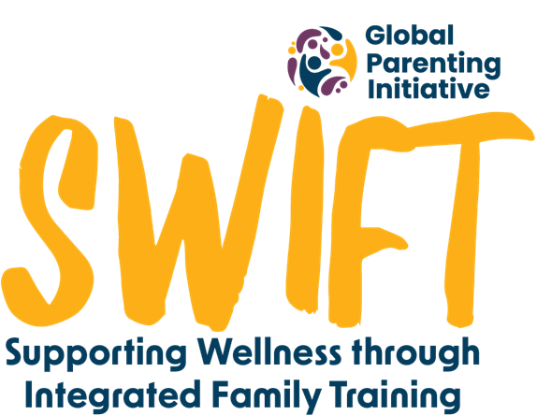


Briefing:

Hi there. Thank you for making the time for this phone call; it won’t take longer than 45 minutes - 1 hour. Is this a convenient time for us to speak? We would like to hear about your experiences of the second module in the ParentText programme, focused on keeping your child safe.

We will be recording this phone call, so we can remember your answers, but your name and your answers will be kept confidential and will only be viewed by the research team. After the interview, the recording will be transcribed, or written down, and then it will be deleted. The written down information will be saved securely on a password protected computer. Do I have your permission to record the interview?

There are no right or wrong answers. You can skip any questions you do not feel comfortable answering. You can also stop this conversation at any time if you wish. If you decide at a later stage that you would like your contribution to be removed from the study, you can contact the research team by email until the [date to be determined].

Do you understand what I’ve just explained? Do you have any questions? Can we begin?

Did you do the content for a teenager/adolescent (ages 10-17) or a child (ages 2-9)? (Make sure you ask the correct set of questions for question 4 depending on how they answer here)

- The second module in ParentText was about keeping your child safe. What part of that module stood out for you? What do you remember?
  - What did you like about this module?
  - What didn’t you like about this module? How can we make it better?

- What did you think of the comics, tips and examples used in the module?
  - How helpful were they?
  - Did it feel relevant to you and your family? How so?
  - Was there anything that you think needed to be changed to fit your culture or community?

- Which of the tips or activities do you remember from the keeping your child safe module?
  - Why did this stand out for you?

- Teen (Please go to Question 4 below for child)
If it’s okay with you, I would like to go through each of the daily lessons to discuss your experiences. It would be great if you can comment on what you remember about it, what you liked about it, and what you didn’t like:
(ask the ‘probes’ below only after you have given the participant an opportunity to answer each question)
  - What stands out for you about the ‘community safety’ lesson?
Probe – did you have a discussion with your child about safety in your community after this lesson? How did they respond?
  - What stands out for you about the ‘online safety’ lesson?
Probe – was there anything new that this module made you think about? Were there any new actions you took with your teen because of it (e.g. rules or conversations, etc)?
  - What stands out for you about the ‘preventing sexual violence’ lesson?
Probe - How did you find the way the chatbot “spoke” about this topic?
Probe - Do you feel like this lesson missed anything that’s relevant or important to you when thinking about preventing sexual violence? Can you explain your answer?
  - What stands out for you about the ‘Responding to crises’ lesson?
Probe – After doing this lesson, was there a time when you found you could use these skills to respond to a crisis with your child? How did this go?
4. Child
If it’s okay with you, I would like to go through each of the daily lessons to discuss your experiences. It would be great if you can comment on what you remember about it, what you liked about it, and what you didn’t like:
(ask the ‘probes’ below only after you have given the participant an opportunity to answer each question)

- What stands out for you about the ‘community safety’ lesson?
Probe – did you have a discussion with your child about safety in your community after this lesson? How did they respond?
- What stands out for you about the ‘online safety’ lesson?
Probe – was there anything new that this module made you think about? Were there any new actions you took with your child because of it (e.g. rules or conversations, etc)?
- What stands out for you in the ‘Teach safe touch’ lesson?
Probe - did this make you think differently at all about the way in which you communicate this with your child? How so?
- What stands out for you about the ‘Responding to crisis’ lesson?
Probe – After doing this lesson, was there a time when you found you could use these skills to respond to a crisis with your child? How did this go?

- How did you feel speaking to your child about the safety module? Which of the lessons did you share with your child? And which didn’t you?
  - The things which you didn’t speak to them about – What do you think stopped you? Is there something which could be added to the programme to support you to have these conversations?
  - The things which you did speak to them about - Why were these easier? What was it that helped you to have these conversations?

- What changes did you see in keeping your child safe?
  - When you worked through this module, what did it bring up for you which you perhaps were not aware of before?
  - Were there things which came up after doing this module which you felt more prepared to manage? Please share?
  - Is there something which you wish was included that wasn’t?
  - Did your child share with you anything which shows that the content of this module helped them?

- Did you use the referral menu for anything while doing this module?
  - Would you mind sharing with me what that was?
  - Did it help? What actions did you take after accessing the information through the chatbot?
  - Was there information which you felt was missing on that help page considering the keeping your child safe module?

Debriefing

Is there anything that we haven’t spoken about that you’d like us to know?

If there was anything that made you feel worried or unsettled while doing this interview, remember you can still access the referrals in the programme by typing ‘help’. SADAG might be a good option. If you have any other questions about the study, you can also send us a WhatsApp or email. Our contact information is on the consent form we sent you.
We’ve come to the end of our interview. Thanks again for taking the time to speak with us today. Your responses have been very helpful!

